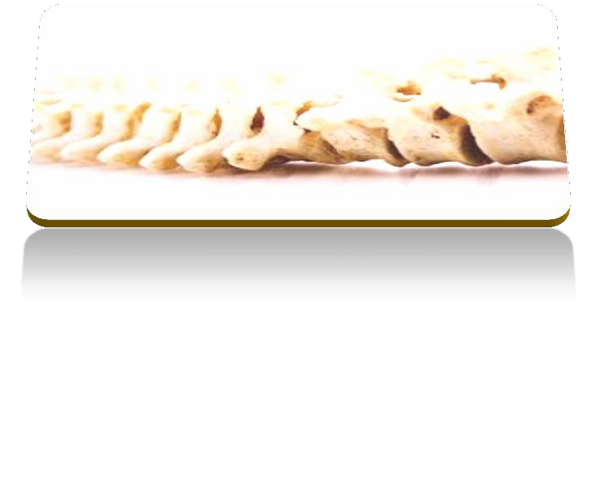

PROFESSIONAL DIPLOMA IN

MANUAL THERAPY
8th intake

Egypt Cairo
April - July 2015 13 Days of teaching
4 month of distance learning

The aim of this diploma program is to provide physiotherapists and medical doctors with a clear and simple framework of clinical reasoning to apply a wide range of manual therapy assessment and treatment techniques for patients with musculoskeletal conditions. The program will stimulate your thinking to reflect on and improve your current clinical practice by adding more practical skills that could be used, for a reason, to maximize the treatment outcomes.
The program is structured and planned according to the guidelines of the international federation of orthopedic manual therapy.
Program Tutors:

Mahmoud Saad

I'm HCPC registered physiotherapist and member of the chartered society physiotherapy- UK with 15 years' experience in the field. I'm Physiotherapy Senior Lecturer at Sheffield Hallam University-UK teaching at postgraduate level and
leading the musculoskeletal module at the physiotherapy MSK master program. I'm clinical Director of primephysio clinis in Sheffield and Rotherham in the UK. My clinical interest is Musculoskeletal and sports injuries management I worked as a senior physiotherapist with Rotherham united football club in the FA league-UK. I'm also certified McKenzie Therapist with McKenzie institute UK. I'm certified medical taping tutor with medical taping of Netherland. I have delivered over 50 manual therapy and other courses and workshops in UK-Egypt-Oman-Kuwait and Jordan. Currently I'm persuading a PHD degree in Physiotherapy with focus on the mechanical treatment and exercises for MSK problems. Mahmoud has completed a prestigious post graduate certificate in teaching and learning in higher education in 2006.

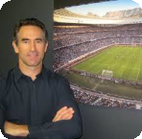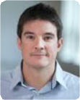

M y l e s B u t l e r

I'm HCPC registered physiotherapist and member of the chartered society physiotherapy- UK with 15 years' experience in the field. I'm Physiotherapy Senior Lecturer at Sheffield Hallam University-UK teaching at
undergraduate and postgraduate level and course leader of practice based physiotherapy course. I worked clinically within the National Health Service in the UK before I start my job at Sheffield Hallam University. Currently I work as musculoskeletal specialist in Rotherham - UK. Although I had my Maitland training on the hands of Kevin Banks (Senior Maitland tutor and Author of Maitland book)early in my career however I have developed my own management approach that address the important role of exercises in management have a master in Teaching and Learning in Higher education.

G e o f f F o a t

Geoff Foat graduated from the University Of Cape Town (UCT) with a Bachelor's degree in Physiotherapy in 1988 and a postgraduate Honors degree in Sport Science in 1989, the latter under the tutelage of Prof. Tim Noakes. In 1991 he moved to Connecticut in the USA, where he was Manager of Physical Therapy (Physiotherapy) at the Center for Orthopedics from 1998 to 2004
In 2002 he graduated with distinction from Quinnipiac University in the USA with a Master's degree in Orthopedic Physical Therapy. An American citizen, Geoff is recognized in the USA as an Orthopedic Certified Specialist (OCS) by the American Physical Therapy Association, and as a Certified Strength and Conditioning Specialist (CSCS) with the National Strength and Conditioning Association.
Brian Mulligan, a world renowned New Zealand physiotherapist and founder of the Mulligan Concept, has been his mentor since 1996. Geoff received full international teaching accreditation in the Mulligan Concept in Rome in 2002.
He is the only accredited instructor in Africa in the Mulligan Concept, and has taught in South Africa and internationally in the USA, Thailand, Egypt and Brazil.
Geoff will be teaching the official mulligan basic 4 days course as part of the program.

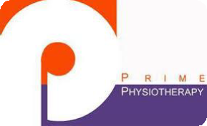
Teaching Schedule

Title | Date | Tutor
Manual therapy for upper quadrant  4 Days  Introduction to Manual Therapy principles Cervical and thoracic spine  Shoulder and elbow | 16-17-18-19 April 2015 | Mahmoud Saad
Manual therapy for lower quadrant  3 Days  Lumbar spine -Hip and Knee | 14-15-16 May 2015 | Myles Butler
Mulligan Basic course 4 Days  Upper quadrant and lower quadrant | 28-29-30-31 May 2015 | Geoff Foat
Advanced treatment techniques and reasoning. 2 Days  Practical Revision Case studies Exam Revision | 24-25- July 2015 | Mahmoud Saad
MCQ and Practical Exam | 26 July 2015

- This program runs for the 8th time, Total number of previous participants in the last 7 programs is 200 physiotherapists.
- The amount of theory to practical is 30/70.
- Priority for those in our waiting list from last program. So limited places. Topics to be covered in the face to face teaching days (All Practical)
- Spine and joints biomechanics.
- Red flags
- Subjective examination
- Objective examination-Validity
- Treatment planning
- Treatment approaches- clinical reasoning
- Mechanical treatment (McKenzie)
- Mobilisation and manipulation techniques
- Exercise therapy
10. Neurodynamics
11. Soft tissue management (loading strategies- facilitation techniques)

Distance Learning Component will cover the following topics:

- Reading research article
- Pain and Neurodynamics
- Core stability
- Elective topic

Example of the practical Techniques to be Exam: covered (total number of techniques is 160 +)

Joints Assessment and treatment :
Soft Tissue Assessment and treatment :

- Accessory and Physiological mobilization for peripheral joints
- Assessment and management of tendonpathy

- Accessory and physiological mobilization techniques for cervical, thoracic and lumbar spine.
- Core stability principles

- Scapular stabilization techniques

- Differential diagnosis for peripheral joints conditions

- differential diagnosis for spinal problems

- Assessment techniques for Sacro-Iliac Joint
  - Rotator cuff activation

  - Proximal control activation

  - Neurodynamics techniques Rehabilitation principles :

- Mobilization techniques for Sacroiliac joint
- Principles of effective rehabilitation

- Manipulation techniques for thoracic and lumbar spine

- Mechanical Treatment of Spinal and peripheral joints.
- Mechanical treatment for soft tissues

- Education techniques

- Mobilization with movement. Mulligan

Practical exam: To evaluate your handling skills in relation to assessment and treatment techniques

MCQ exam: 50 MCQ questions to evaluate your understanding of the essential knowledge and clinical reasoning within Manual therapy practice

.

PRIMEPHYSIO www.primephysio.com

Diploma Fees:  Early Bird registration: | Before 30th March 2015 | 5600 Egyptian pound
Normal Registration: | After 30th March 2015 | 5800 Egyptian pound

Only a deposit of 1000 pound (unrefundable) is required to book your place.

Rest of fees could be paid over two equal installments

Please note, Due to the time limitation and the complicated logistic of the program, the course fees are non-refundable

This cost covers:

- Distance learning program

- Attendance of All the teaching blocks

- Certificate of attendance for each teaching block by Primephysio

- Certificate of attendance for the diploma program

- Soft copy of all learning materials

- Coffee breaks Only

- Exam fees

How to Register:

Please TEXT primephysio organization team for details or call between 3-5 pm ONLY 01226675050 - 0167990006- 01002087891- 01099057404
For Registration from Overseas please Email primephysio@primephysio.com

Registered training provider in wales and England www.primephysio.com

